# Add new company

Adding a new company is initialized from the companies grid page.

We create a button “Add company” (label is translatable).

Upon clicking the button, we go to a new page, first a generic search box is presented:

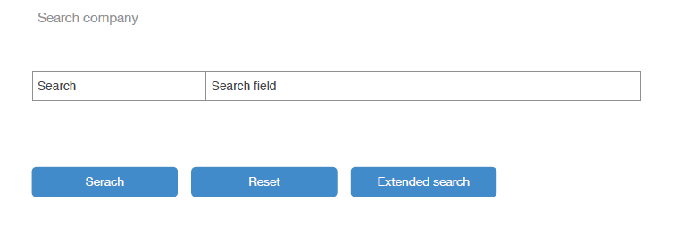

This box will search our local chamber of commerce for the search term**. For this an existing API will be used. See included php file for a prototype class. This php file starts with credentials (commented), please put those in the ENV file of your project.**

In the first screen a generic “term” argument can be used. Extended search will open more search fields:

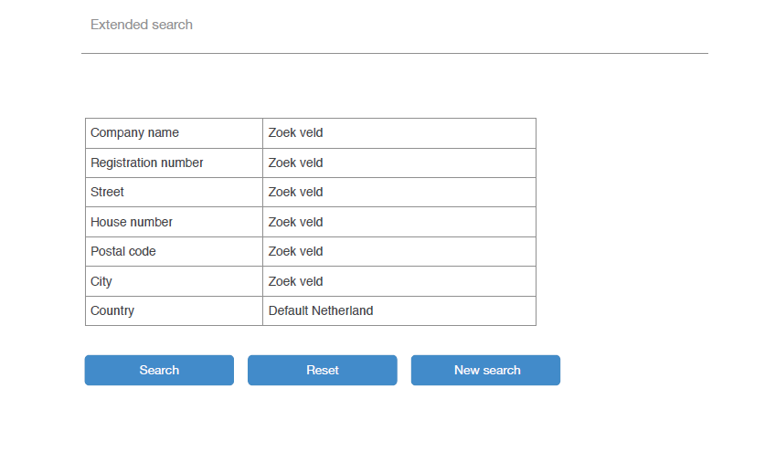

Each field translates to the search api search parameters (see php script).

**Not mentioned in these wireframes is a button to directly go to a form which allows you to go to the edit-screen where you can manually enter all details.**

## Search result

Upon searching (by the generic term, sketch 1, or the advanced seach, sketch 2), the results page is opened:

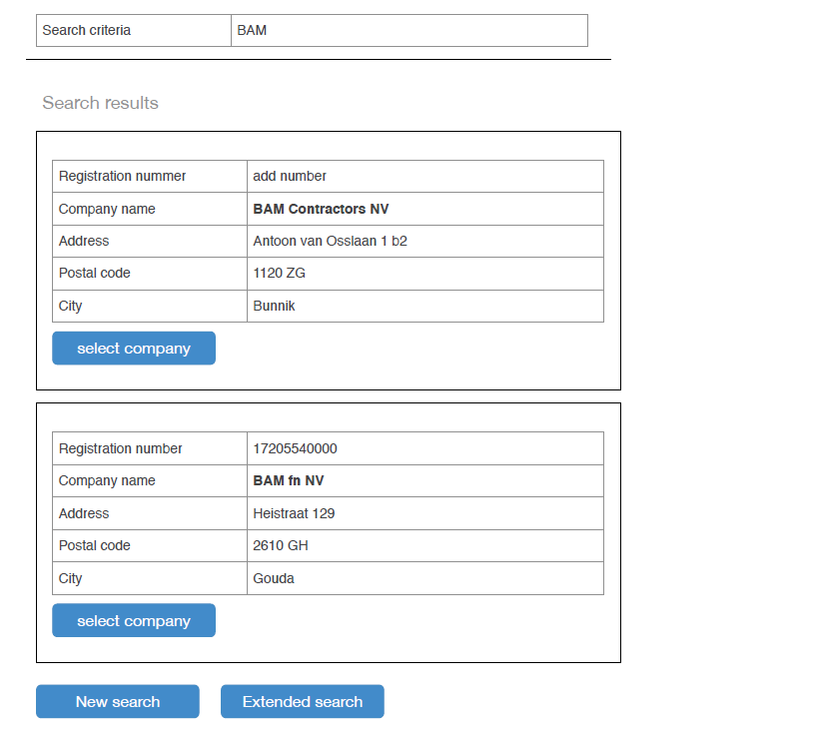

Be aware that the search form is included in the search results. The best approach will be: appending the data to the form.

Clicking on “select company” will forward the user to the edit screen.

screen above.

Here the data from the search result is filled in the form.

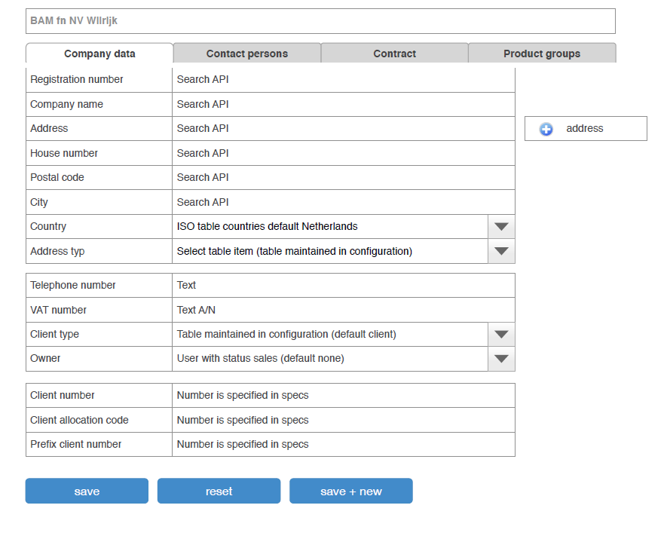

Please ignore the tabs “Contract” and “product groups” for now, they will not be implemented yet. But bear in mind that there can be more tabs added in the future, and see the “Address” paragraph below.

Either the user has skipped search, or has selected a company from the search to reach the edit

### Address

The field address type can be removed, this should ALWAYS be of the type “office”. This cannot be changed. The address stored here will also be the “primary” address in all cases.

Please ignore also the button “+ address” on the right. This will be an extra tab.

## Client number

The **client number** field should be auto-generated (auto incremented): from the distribution partner table you take the latest company_number_index, increment this with 1 and put the company_number_prefix in front. So the client number in the form will be for instance CD2. After saving the company as a NEW COMPANY, you will increment company_number_index with 1. So next time, the client number for a new client will be CD3.

**Client allocation number** is a free entered client number, the user can enter a free number here.

The field **prefix client number** can be ignored, do not add this to your form